SCIENTIFIC (MOLE)THOD
Inquiry Activity
The teacher will give the class on object with an irregular shape. The class must cooperate to develop a plan to answer the following questions. All data and procedures must be written in the lab notebook.
- How many moles of the object will fit inside Room 410?

- If you had a mole of the object, what fraction of the room or how many rooms would be needed to hold all of them?

- If the object was fit end to end how long would the line be?

- What did you learn from this exercise?
As you do any measurements, be aware of significant figures. Significant figures include all KNOWN numbers plus one estimate.
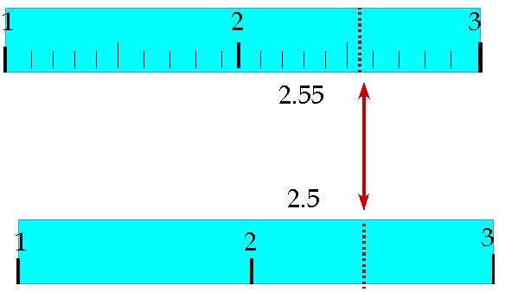

YES, you must estimate between the lines of the meter stick.

